

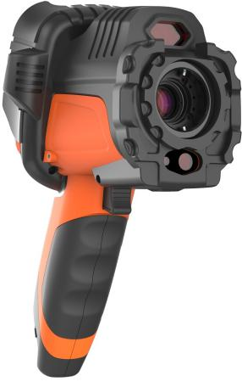

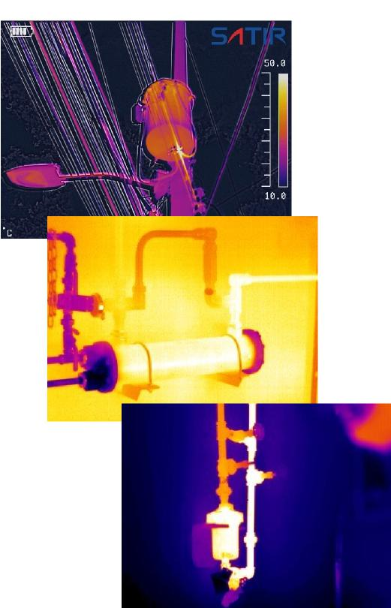

**D300**





**Mid Level Thermal Camera**



SATIR D300 has been designed with the user in mind to ensure that it is simple to use while delivering a high quality image with a 384x288 resolution.

The D300 comes with a laser ranging feature which allows the user to point the laser to the target and it automatically focus the image.

The D300 comes with Duo Vision Plus and a touch screen.

Duo Vision Plus add additional clarity to the thermal image by using a digital overlay. Duo Vision Plus also works well with it’s touch screen that will auto focus to ensure the user has a clearly focused thermal image. This means when generating a report the image is already focused which enables accurate evaluation.

**Key Features**

- High Speed Processor

- IR/Digital/Duo-Vision/Duo Vision Plus

- Laser Ranging

- Adaptable LCD Display

- Motorised Lens

- 5 MP HD Camera

- 8 Hours of Battery Life



**D300**

**Specifications**

|  |  |
| --- | --- |
| **Image Performance** |  |
| Detector Resolution | 384x288 |
| Thermal Sensitivity (N.E.T.D) | ≤0.04°C@30°C |
| Spatial Resolution | 1.09mrad |
| Field of View (F.O.V) | 24°x17° |
| Spectral range | 7.5~14μm |
| Focus Mechanism | Motorised |
| **Measurement** |  |
| Temperature Range | -40°C ~ + 1500°C |
| Accuracy | ±2°C or ± 2% of readings |
| **Image Presentation** |  |
| Image Mode | IR/Digital/Duo-Vision/Duo-Vision Plus |
| Visible Pixels | HD 5MP Digital Camera |
| LCD Display | 3.5” Capacitive Touch Screen |
| Frame Rate | 50Hz / 60 Hz |
| Digital Zoom | 1x to 10x, continuous |
| Video auto record | Every 4 seconds |
| Image Output Mode | Analogue Video Output |
| File Format (Thermal/Visual) | JPEG |
| **Laser** |  |
| Laser Type | Class 2, 1mW/635nm, red |
| Laser Ranging | Yes—Auto focus the camera |
| Measurement Range | 0.05m—30m |
| **Environmental** |  |
| Encapsulation | IP54 |
| Shock/Vibration Resistance | 25G/2G |
| Operating Temperature | -20°C ~ +50°C |
| **Physical Characteristics (Camera Body)** |  |
| Weight | 0.85KG |
| Dimensions | 232mm×115mm×168mm |
| **Additional Features** |  |
| Built-in Memory | Yes |
| Battery Life | 8 Hours |
| Ports | USB Type C |
| Video Record | Yes |
| Bluetooth | Yes (Optional) |
| Real time transmission | USB real time transmission with temperature data (optional) |

**Please be aware specifications can vary from time to time**

