

**D600**

**Performance Level Thermal Camera**

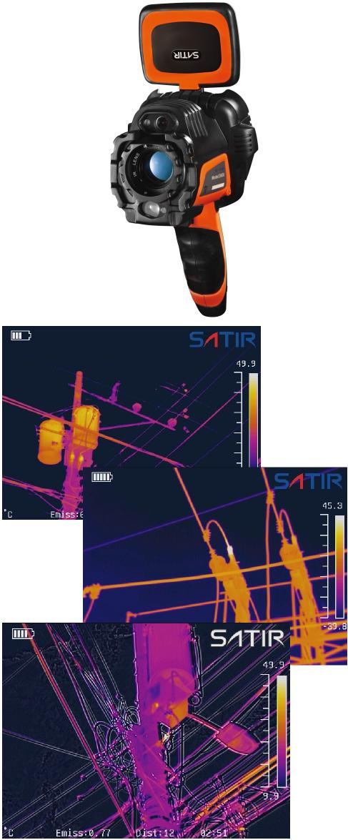







SATIR D600 is our newest addition to the

D-Series, it is a high performance handheld IR camera which delivers high quality Images and thermal videos with it’s 640x480 IR detector.

The D600 has a range of imaging modes which includes Duo-Vision Plus which is SATIR latest innovative imaging technology. Duo Vision merges a infrared and visual image to deliver a highly detailed image to the user for analysis when carrying out a thermal survey.

The D600 comes with a touch screen that will auto focus to ensure the user has a clearly focused thermal image. This means when generating a report the image is already focused which enables accurate evaluation.

**Key Features**

- Digital Zoom

- IR/Digital/Duo-Vision/Duo Vision Plus

- Laser Pointer

- 8 Hours Battery Life

- Adaptable LCD Display

- Easy to use interface

- 5 MP High Definition Camera

- Thermal Video Recording



**D600**

**Specifications**

|  |  |  |
| --- | --- | --- |
| **Image Performance** |  |  |
| Detector Resolution | 640x480 |  |
| Thermal Sensitivity (N.E.T.D) | ≤0.05°C@30°C |  |
| FOV/Min. Focus Distance | 24°x18°/0.20m |  |
| Spectral Range | 8-14µm |  |
| Spatial Resolution | 0.65 mrad |  |
| Focus Mechanism | Manual/Motorised/Auto |  |
| **Measurement** |  |  |
| Temperature Range | -20°C ~ + 600°C, up to +1500°C (Optional) |  |
| Accuracy | ±2°C or ± 2% of readings |  |
| Measurement Mode | 8 Movable Spots, Auto Hot/Cold Spot,profile, isotherm, line | 2 area boxes, |
| Alarm | Yes |  |
| **Image Presentation** |  |  |
| Image Mode | IR/Digital/Duo-Vision/Duo Vision Plus |  |
| Visible Pixels | HD 5MP Digital Camera |  |
| LCD Display | 3.5” Capacitive Touch Screen |  |
| Image Output Mode | NTSC (60Hz) or PAL (50Hz) Composite Video |  |
| File Format (Thermal/Visual) | JPEG ( Thermal/Visual) |  |
| **Power System** |  |  |
| Battery Type | Built-in Rechargeable Lithium-ion Battery |  |
| Charge Interface | Type-C |  |
| Power Manage | Auto Shut Off/Sleep Mode |  |
| **Environmental** |  |  |
| Encapsulation | IP54 |  |
| **Physical Characteristics** |  |  |
| Weight | 0.85KG |  |
| Dimensions | 232mm×115mm×168mm |  |

**Please be aware specifications can vary from time to time**

